Design a Restaurant Management system
Let's design a restaurant management system.
A Restaurant Management System is a software built to handle all restaurant activities in an easy and safe manner. This System will give the Restaurant management power and flexibility to manage the entire system from a single portal. The system allows the manager to keep track of available tables in the system as well as the reservation of tables and bill generation.
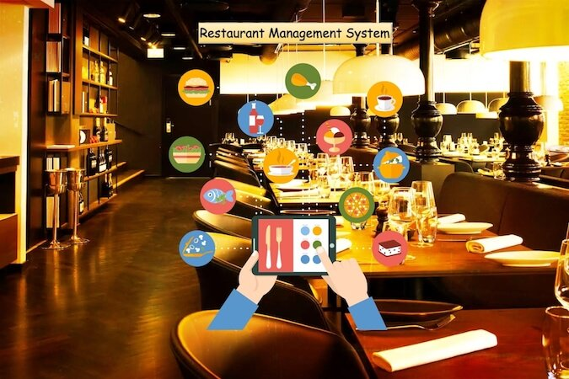

System Requirements
We will focus on the following set of requirements while designing the Restaurant Management System:
- The restaurant will have different branches.
- Each restaurant branch will have a menu.
- The menu will have different menu sections, containing different menu items.
- The waiter should be able to create an order for a table and add meals for each seat.
- Each meal can have multiple meal items. Each meal item corresponds to a menu item.
- The system should be able to retrieve information about tables currently available to seat walk-in customers.
- The system should support the reservation of tables.
- The receptionist should be able to search for available tables by date/time and reserve a table.
- The system should allow customers to cancel their reservation.
- The system should be able to send notifications whenever the reservation time is approaching.
- The customers should be able to pay their bills through credit card, check or cash.
- Each restaurant branch can have multiple seating arrangements of tables.

Use case diagram
Here are the main Actors in our system:
- Receptionist: Mainly responsible for adding and modifying tables and their layout, and creating and canceling table reservations.
- Waiter: To take/modify orders.
- Manager: Mainly responsible for adding new workers and modifying the menu.
- Chef: To view and work on an order.
- Cashier: To generate checks and process payments.
- System: Mainly responsible for sending notifications about table reservations, cancellations, etc.
Here are the top use cases of the Restaurant Management System:
- Add/Modify tables: To add, remove, or modify a table in the system.
- Search tables: To search for available tables for reservation.
- Place order: Add a new order in the system for a table.
- Update order: Modify an already placed order, which can include adding/modifying meals or meal items.
- Create a reservation: To create a table reservation for a certain date/time for an available table.
- Cancel reservation: To cancel an existing reservation.
- Check-in: To let the guest check in for their reservation.
- Make payment: Pay the check for the food.
Use case diagram

Class diagram
Here is the description of the different classes of our Restaurant Management System:
- Restaurant: This class represents a restaurant. Each restaurant has registered employees. The employees are part of the restaurant because if the restaurant becomes inactive, all its employees will automatically be deactivated.
- Branch: Any restaurants can have multiple branches. Each branch will have its own set of employees and menus.
- Menu: All branches will have their own menu.
- MenuSection and MenuItem: A menu has zero or more menu sections. Each menu section consists of zero or more menu items.
- Table and TableSeat: The basic building block of the system. Every table will have a unique identifier, maximum sitting capacity, etc. Each table will have multiple seats.
- Order: This class encapsulates the order placed by a customer.
- Meal: Each order will consist of separate meals for each table seat.
- Meal Item: Each Meal will consist of one or more meal items corresponding to a menu item.
- Account: We’ll have different types of accounts in the system, one will be a receptionist to search and reserve tables and the other, the waiter will place orders in the system.
- Notification: Will take care of sending notifications to customers.
- Bill: Contains different bill-items for every meal item.
Class diagram

Activity diagrams
Place order: Any waiter can perform this activity. Here are the steps to place an order:
Make a reservation: Any receptionist can perform this activity. Here are the steps to make a reservation:
Cancel a reservation: Any receptionist can perform this activity. Here are the steps to cancel a reservation:

Code
Here is the high-level definition for the classes described above.
Enums, data types, and constants: Here are the required enums, data types, and constants:
public enum ReservationStatus {
REQUESTED, PENDING, CONFIRMED, CHECKED_IN, CANCELED, ABANDONED
}

public enum SeatType {
REGULAR, KID, ACCESSIBLE, OTHER
}

public enum OrderStatus {
RECEIVED, PREPARING, COMPLETED, CANCELED, NONE
}

public enum TableStatus {
FREE, RESERVED, OCCUPIED, OTHER
}

public enum AccountStatus {
ACTIVE, CLOSED, CANCELED, BLACKLISTED, BLOCKED
}

public enum PaymentStatus {
UNPAID, PENDING, COMPLETED, FILLED, DECLINED, CANCELLED, ABANDONED, SETTLING, SETTLED, REFUNDED
}

public class Address {
private String streetAddress;
private String city;
private String state;
private String zipCode;
private String country;
}

Account, Person, Employee, Receptionist, Manager, and Chef: These classes represent the different people that interact with our system:

// For simplicity, we are not defining getter and setter functions. The reader can
// assume that all class attributes are private and accessed through their respective
// public getter methods and modified only through their public setter function.

public abstract class Account {
private String id;
private String password;
private Address address;
private AccountStatus status;

public boolean resetPassword();
}

public abstract class Person extends Account {
private String name;
private String email;
private String phone;
}

public class Employee extends Person {
private int employeeID;
private Date dateJoined;
}

public class Receptionist extends Employee {
public boolean createReservation();
public List<Customer> searchCustomer(String name);
}

public class Manager extends Employee {
public boolean addEmployee();
}

public class Chef extends Employee {
public boolean takeOrder();
}

Restaurant, Branch, Kitchen, TableChart: These classes represent the top-level classes of the system

public class Kitchen {
private String name;
private Chef[] chefs;

private boolean assignChef();
}

public class Branch {
private String name;
private Address location;
private Kitchen kitchen;

public Address addTableChart();
}

public class Restaurant {
private String name;
private List<Branch> branches;

public boolean addBranch(Branch branch);
}

public class TableChart {
private int tableChartID;
private byte[] tableChartImage;

public bool print();
}

Table, TableSeat, and Reservation: Each table can have multiple seats and customers can make reservations for tables:

public class Table {
private int tableID;
private TableStatus status;
private int maxCapacity;
private int locationIdentifier;

private List<TableSeat> seats;

public boolean isTableFree();
public boolean addReservation();

public static List<Table> search(int capacity, Date startTime) {
// return all tables with the given capacity and availability
}
}

public class TableSeat {
private int tableSeatNumber;
private SeatType type;

public boolean updateSeatType(SeatType type);
}

public class Reservation {
private int reservationID;
private Date timeOfReservation;
private int peopleCount;
private ReservationStatus status;
private String notes;
private Date checkinTime;
private Customer customer;

private Table[] tables;
private List<Notification> notifications;
public boolean updatePeopleCount(int count);
}

Menu, MenuSection, and MenuItem: Each restaurant branch will have its own menu, each menu will have multiple menu sections, which will contain menu items:

public class MenuItem {
private int menuItemID;
private String title;
private String description;
private double price;

public boolean updatePrice(double price);
}

public class MenuSection {
private int menuSectionID;
private String title;
private String description;
private List<MenuItem> menuItems;

public boolean addMenuItem(MenuItem menuItem);
}

public class Menu {
private int menuID;
private String title;
private String description;
private List<MenuSection> menuSections;

public boolean addMenuSection(MenuSection menuSection);
public boolean print();
}

Order, Meal, and MealItem: Each order will have meals for table seats:

public class MealItem {
private int mealItemID;
private int quantity;
private MenuItem menuItem;

public boolean updateQuantity(int quantity);
}

public class Meal {
private int mealID;
private TableSeat seat;
private List<MenuItem> menuItems;

public boolean addMealItem(MealItem mealItem);
}

public class Order {
private int OrderID;
private OrderStatus status;
private Date creationTime;

private Meal[] meals;
private Table table;
private Check check;
private Waiter waiter;
private Chef chef;

public boolean addMeal(Meal meal);
public boolean removeMeal(Meal meal);
public OrderStatus getStatus();
public boolean setStatus(OrderStatus status);
}

